GAME FEATURE PLANNING
& DESIGN DOCUMENT
A 2D puzzle-adventure feature built around recording and replaying the player's
past movement as a temporary shadow echo.
Internship | Yuvalntern — Junior Game Developer
Task | Week 1 — Game Feature Planning and Design
Feature Type | Core gameplay / puzzle system
Target Platform | PC first; adaptable to mobile/controller
Prototype Engine | Unity 2D (recommended)
Estimated Planning +  Prototype | 34 hours

Prepared as a structured Week 1 design document covering concept, mechanics, research basis, interaction, technical design, diagrams, pseudocode, risks, testing, balance, novelty, and implementation roadmap.
- Executive Summary
Shadow Memory is a compact 2D puzzle feature in which the player records a sequence of movements and actions, then creates an Echo that replays the sequence. The player remains active while the Echo repeats the recorded behavior. This creates cooperative puzzles between the present player and their past self without requiring a second human player.
The feature is intentionally scoped for a practical prototype: one character controller, a short recording buffer, deterministic replay, pressure plates, doors, hazards, checkpoints, and a small set of tutorial rooms. The same system can later support more complex puzzle types.

Core design promise
“Your past becomes your partner.” The player solves problems by planning what their Echo should do, then using the present character to complete the complementary action.

Document contents
- 2. Background Research and Design Rationale
- 3. Game Concept and Feature Goals
- 4. Core Mechanics and Player Experience
- 5. User Interaction and Controls
- 6. Level / Puzzle Design and Balance
- 7. Conceptual Diagrams and System Architecture
- 8. Technical Requirements
- 9. Pseudocode and Internal Logic
- 10. Technical Challenges and Solutions
- 11. UI / UX and Accessibility
- 12. Art, Audio and Content Requirements
- 13. QA and Test Strategy
- 14. Implementation Roadmap — 34 Hours
- 15. MVP, Risks and Future Expansion
- 16. Success Metrics and Evaluation
- 17. Conclusion and References
- Background Research and Design Rationale
The research basis for this feature is the study of established puzzle-design patterns rather than copying a specific game. The feature combines four familiar design ideas: delayed/recorded actions, spatial puzzle solving, state-based switches, and short iterative attempts.

Relevant design patterns
Pattern | How it is used | Design benefit
Action replay | A previous input sequence is stored and replayed by an Echo. | Turns time into a puzzle resource and gives the player a visible cause-and-effect loop.
Spatial puzzle | Rooms contain plates, doors, hazards and restricted paths. | Creates clear goals and allows difficulty to scale by layout.
State change | A plate can open a door or deactivate a barrier. | Makes player actions readable and testable.
Iteration | The player can restart and record a new attempt quickly. | Keeps experimentation low-cost and supports learning through failure.

Design opportunity
Many simple puzzle prototypes depend on a single character manipulating objects one at a time. Shadow Memory adds a second controllable presence without requiring complicated Al. The Echo is deterministic: it follows recorded input/actions. This reduces unpredictability and makes the system easier to debug than a free-roaming AI companion.

Novelty position
The feature is designed to feel distinct through its specific combination of short movement recording, simultaneous present/past interaction, and readable 2D presentation. It should not be described as globally unique; instead, the design goal is a clear, original implementation suitable for an internship prototype.

Research / reference areas
- Puzzle-game design principles: clear goals, readable rules, constrained interaction, progressive complexity.
- Replay systems: deterministic event/input recording is preferred over recording full world state for the prototype.
- Unity 2D development: Rigidbody2D/Collider2D, trigger events, UI, input actions, prefabs and scene-based level organization are suitable implementation building blocks.
- Playtesting practice: introduce one mechanic at a time, observe where players fail, then adjust timing, room layout and feedback.

Reference resources for implementation
Unity Manual — 2D game development: https://docs.unity3d.com/Manual/2D.html
Unity Input System documentation: https://docs.unity3d.com/Packages/com.unity.inputsystem@latest/
Unity Physics 2D documentation: https://docs.unity3d.com/Manual/Physics2D.html
- Game Concept and Feature Goals

Working title: Shadow Memory

Genre
2D puzzle-adventure / logic game.

High-level premise
The player explores compact rooms where some actions cannot be completed at the same time by one character. The player records a movement sequence. On replay, a translucent Echo repeats that sequence while the player performs another sequence. Correct coordination opens the route to the exit.

Primary feature goals
- Make the player think in sequences rather than only reacting moment-to-moment.
- Provide immediate feedback after recording and replaying.
- Keep the core mechanic understandable within the first tutorial room.
- Allow failure to be cheap: restart, re-record and retry in seconds.
- Create increasing puzzle depth without requiring complex enemy Al.
- Keep the prototype small enough to implement and test within the internship schedule.

Target experience
The desired emotional sequence is: curiosity -> experimentation -> confusion discovery -> satisfaction.
The player should feel responsible for the solution because the Echo only performs actions they intentionally recorded.

Feature boundaries
Out of scope for MVP
In scope
Movement recording and replay
Online multiplayer
Pressure plates and doors
Restart / checkpoint system
Basic hazards
Tutorial + 5-8 rooms
Procedural level generation
Complex combat Al
Large open-world map
Full narrative campaign
- Core Mechanics and Player Experience
The feature uses a simple three-phase loop.
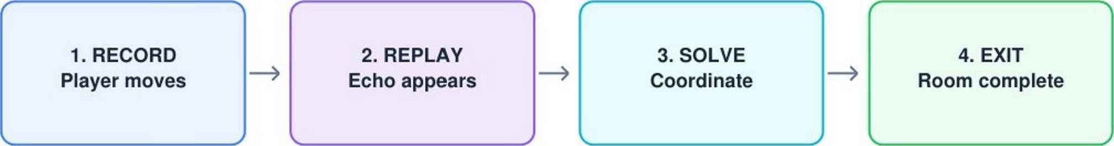

Core gameplay loop
- Record: press Record and move through the room. Relevant actions and movement samples are captured.
- Finish recording: press the same key or reach the recording limit.
- Spawn Echo: the game creates a temporary shadow character at the recording start position.
- Replay: the Echo follows the recorded sequence while the player regains control.
- Coordinate: use the Echo to hold a plate, trigger a switch, distract a hazard, or reach a timed position.
- Complete: when the exit condition is satisfied, the player moves through the exit and the room ends.

Core mechanics
Mechanic | Description | Purpose
Recording | Store player movement/action events for a short window. | Creates the player’s past self.
Echo replay | Spawn an Echo and replay events in the same timing order. | Enables simultaneous actions.
Pressure plate | Plate changes state while the player/Echo overlaps it. | Creates cooperation puzzles.
Door | Door opens when its linked condition is true. | Provides a clear room goal.
Hazard | Contact or timed area resets the active attempt/checkpoint. | Adds risk and timing decisions.
Checkpoint | Stores room state before a harder puzzle segment. | Reduces frustration.

Example puzzle room
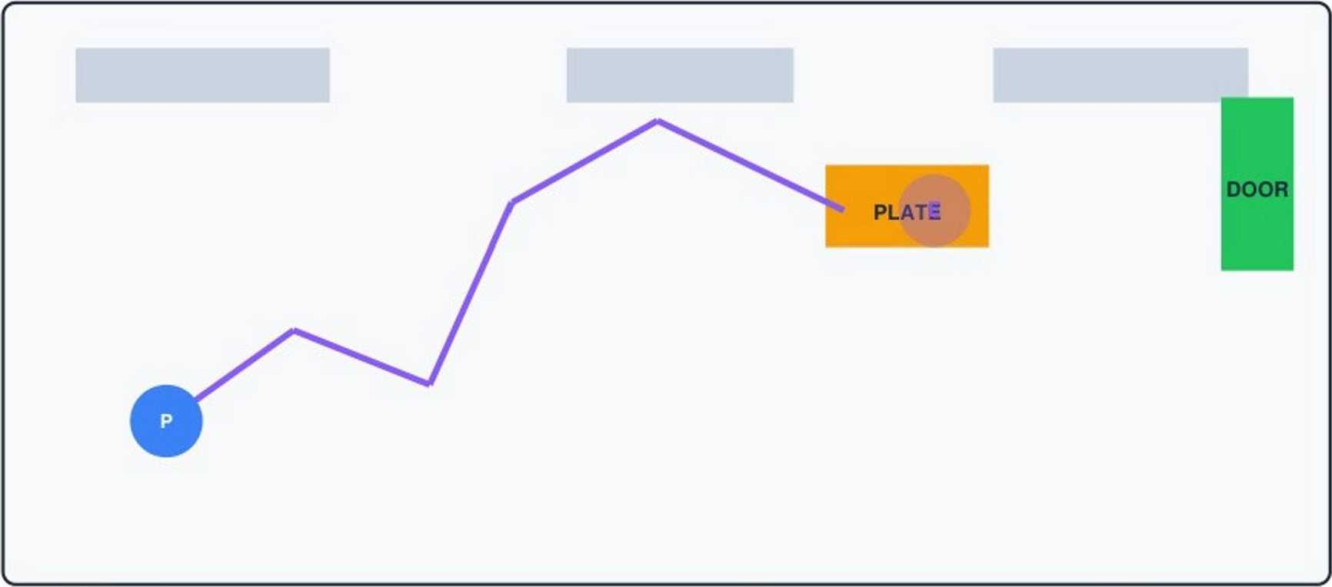
Player Echo / recorded shadow | Pressure plate | Exit

Example: the player first walks to the pressure plate and records that route. During replay, the Echo stands on the plate. The player then takes a different route through the newly opened door.
- User Interaction and Controls
The prototype uses a minimal control scheme so the puzzle system—not control complexity—is the focus.

Action | Keyboard | Controller (optional) | Feedback
Move | WASD / Arrow Keys | Left Stick | Character movement + footstep sound
Start / stop recording | R | Button South / X | REC indicator + timer
Restart room | T | Shoulder button | Short reset animation
Pause | Esc | Menu / Start | Pause overlay

User interaction points
- Before recording: UI displays the recording limit and a short instruction.
- During recording: a visible REC label, timer and subtle trail show that the player is creating an Echo.
- During replay: the Echo is translucent/purple and a small “ECHO ACTIVE” indicator confirms the system is running.
- When a plate is activated: use a short visual pulse and sound cue.
- When a door opens: show a brief animation and optional icon linking the plate to the door.
- On failure: explain the immediate reason when possible (e.g., “Echo left the plate too early”).
- On success: freeze briefly, show “Room Complete,” then offer Next Room / Replay.

Player feedback principles
Every important system state should have at least two signals where practical: visual + audio. For example, an activated plate changes color and plays a click; the Echo becomes more opaque when actively interacting with an object.
- Level / Puzzle Design and Balance
The feature should teach one rule at a time, then combine rules. The first rooms are intentionally small so the player can understand cause and effect.
Room | New idea | Puzzle requirement | Target difficulty
1 — First Echo | Record + replay | Echo walks to plate | Very low
2 — Split Path | Different routes | Player and Echo take separate paths | Low
3 — Timed Door | Timing | Echo holds plate long enough | Low-medium
4 — Hazard | Risk | Record a safe route around hazard | Medium
5 — Two-State Room | Sequence planning | Plate + switch order | Medium
6-8 — Combination | Combined rules | Multi-step Echo plan | Medium-high

Balance rules
- Recording window starts around 8 seconds in the first prototype and can increase/decrease per room.
- The player should normally understand why a solution failed; avoid invisible timing requirements.
- Restart should take less than 2 seconds after the input is pressed.
- A puzzle should introduce at most one major new rule at a time.
- Optional challenge: solve with fewer recordings, shorter time, or a cleaner route.
- Avoid requiring pixel-perfect movement in the MVP; use forgiving trigger areas.
- If a room has a timed element, provide a visible timer or clear audio cue.

Balancing variables
Variable | Effect of increasing it | How to tune
Recording duration | More actions possible; less restrictive | Per-room configuration
Echo speed | Changes timing windows | Default 1.0x; test 0.8-1.2
Plate activation time | Changes required coordination | Door/plate configuration
Hazard density | Raises execution difficulty | Increase gradually

- Conceptual Diagrams and System Architecture

Feature state flow
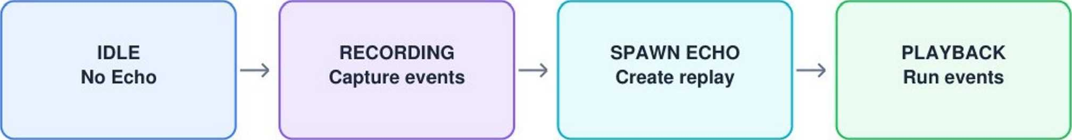

At the end of playback, the Echo can disappear, loop if the room requires it, or remain stationary depending on the puzzle rule. The MVP uses one Echo and one playback pass.

High-level technical architecture
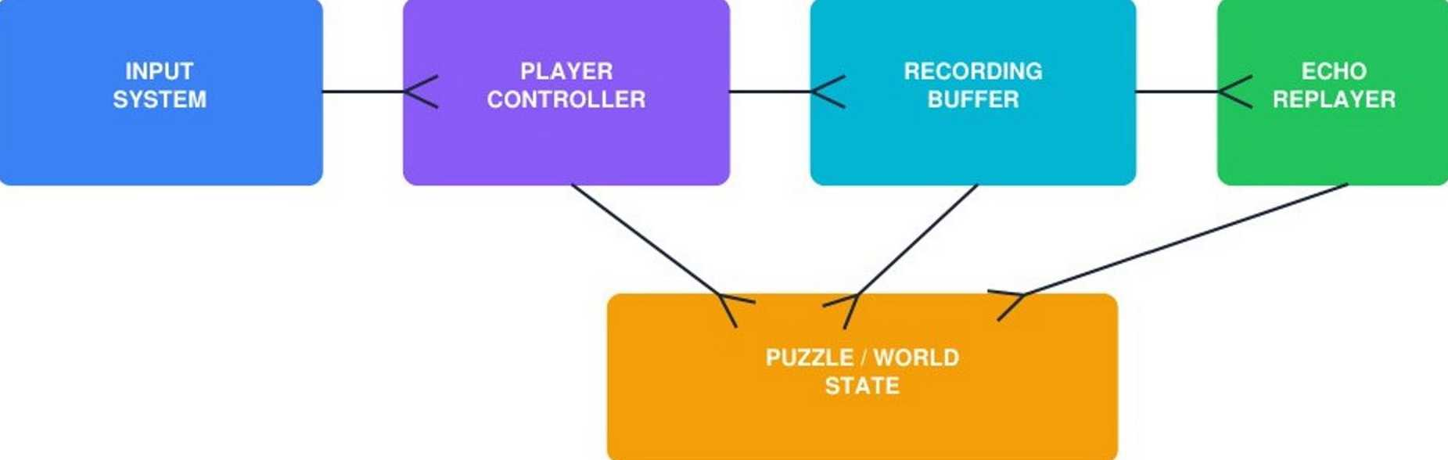

Data flow
Input -» Player Controller -> Recording Buffer -> Echo Replayer -> World/Puzzle State -> Feedback/UI. The Recording Buffer is the main feature-specific component. The puzzle system should consume normal gameplay events rather than knowing how the recording was created.

Suggested class/module structure
Module | Responsibility
PlayerController | Movement, collision and interaction input.
RecordingManager | Start/stop recording and manage current recording session.
InputEvent / ActionEvent | Stores timestamped movement/action information.
EchoController | Moves the Echo according to recorded data.
PuzzleObject | Common interface for plates, doors, switches and hazards.
LevelManager | Room loading, completion and restart/checkpoint logic.

Responsibility
Module
UlManager
REC state, timer, prompts, completion and error feedback.
- Technical Requirements
Recommended technology stack
Area | Choice | Reason
Engine | Unity 2D | Fast iteration, 2D physics, prefabs, UI and scene workflow.
Language | C# | Native Unity scripting language with clear object-oriented structure.
Input | Unity Input System | Separates actions from device bindings and supports keyboard/controller.
Physics | 2D colliders / triggers | Suitable for plates, walls, hazards and interaction zones.
Data | In-memory event list for MVP | Simple and sufficient for short recordings.
Version control | Git + GitHub | Tracks progress and provides an inspectable project repository.

Hardware / software assumptions
- Development PC: Windows 10/11,8 GB RAM minimum; 16 GB preferred.
- Unity Hub + a current supported Unity LTS release.
- Git installed locally and a GitHub repository for source control.
- Target prototype resolution: 1920x1080 with UI scaling for smaller screens.
- 2D sprites can be placeholder geometric shapes during the first implementation pass.

Recording data model
For a compact prototype, each event can store a timestamp plus the relevant input state. Example fields: time, horizontal input, vertical input, action flags. An alternative is to record sampled position/rotation. Input-event recording is preferred initially because it keeps the data conceptually small and lets the Echo use the same movement controller.

Example event structure
class ActionEvent { float time; Vector2 move; bool interact; } List<ActionEvent> recording; float recordingTimer;

Performance considerations
- Keep recordings short and clear old buffers on restart.
- Do not instantiate a new object every frame; reuse the Echo GameObject.
- Use a fixed sample rate or meaningful action changes instead of storing unnecessary identical input states.
- Keep puzzle objects event-driven where possible so every frame does not require scanning the entire scene.
- Pseudocode and Internal Logic

Recording logic
START_RECORDING recording = empty list timer = 0 recordingActive = true WHILE recordingActive AND timer < maxRecordingTime input = ReadMovementInput () action = ReadActionlnput() IF input changed OR action occurred OR sample interval reached event = CreateEvent(timer, input, action) recording.Add(event) timer = timer + deltaTime IF stop button pressed OR timer >= maxRecordingTime recordingActive = false SpawnEcho(recording)

Echo replay logic
START_ECHO(recording) echoTime = 0 eventindex = 0 echoActive = true WHILE echoActive echoTime = echoTime + deltaTime WHILE eventindex < recording.Count event = recording[eventIndex] IF event.time <= echoTime ApplyMovement(event.move) ApplyAction(event.action) eventindex = eventindex + 1 ELSE BREAK IF eventindex =: recording.Count echoActive = false FinishEchoO

Room completion logic
IF ExitConditionlsSatisfied() ShowSuccessFeedback() SaveCheckpoint() LoadNextRoom() ELSE IF PlayerHitsHazard() ShowFailureFeedback() ResetAttempt()

Simplified feature decision flow
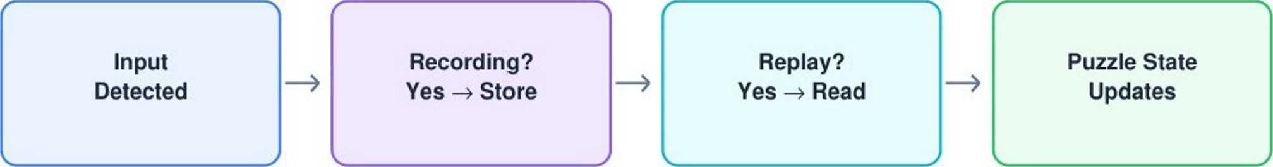

Important implementation rule
The Echo should not independently “decide” what to do. It should replay the recorded sequence. This makes outcomes deterministic and gives the player a clear mental model.
- Technical Challenges and Proposed Solutions
Challenge | Risk | Proposed solution | Fallback
Replay desynchronization | Echo reaches objects at slightly different times. | Use timestamps, fixed physics settings and deterministic movement logic. | Record position samples instead of input events.
Physics differences | Collisions alter the Echo path. | Use controlled movement and simple colliders for MVP. | Kinematic Echo with scripted movement.
Recording too much data | Memory/processing grows unnecessarily. | Cap recording duration and sample only meaningful changes. | Fixed-rate position sampling.
Puzzle state reset | Old states remain after restart. | Central LevelManager resets registered puzzle objects. | Reload scene for early prototype.
Unclear player feedback | Players do not know why puzzle failed. | Visual/audio state cues and simple contextual messages. | Add debug overlay during testing.
Input edge cases | Record begins/stops incorrectly. | Centralize input actions and use explicit state transitions. | Keyboard-only prototype first.

Risk management principle
Prototype the hardest technical risk first: accurate recording and replay. Art polish should not begin until the Echo can reproduce a simple route reliably.
- UI / UX and Accessibility

Minimal HUD concept
Top-left REC • 00:04 / 00:08 Current recording status + timer

Accessibility considerations
- Do not rely on color alone: plate/door states also use icons, animation or text.
- Provide adjustable audio volume and separate effect/music levels if time permits.
- Allow keyboard remapping in the extended version.
- Use high-contrast Echo/player silhouettes against the background.
- Avoid extremely fast timing requirements in the tutorial.
- Use readable font sizes and keep important prompts near the relevant interaction.
- Optional reduced-motion mode can disable nonessential screen effects.

UX principles
- Teach by doing: first room demonstrates recording without text-heavy instructions.
- Fast restart: failure should return the player to a playable state immediately.
- Predictable rules: an Echo does exactly what was recorded.
- Visible causality: when a plate activates, the connected door should visibly respond.
- Consistent language: use “Record,” “Echo,” “Replay,” “Restart," and “Exit” throughout.
- Art, Audio and Content Requirements
The visual style should support readability rather than overwhelm the puzzle. A dark/simple environment with strong silhouettes can make the Echo easy to recognize.

Asset list for MVP
Category | Required assets | Priority
Player | Idle + movement sprite or simple character | High
Echo | Translucent version of player + trail | High
Environment | Floor, wall, door, background tiles | High
Puzzle | Pressure plate, switch, exit | High
Hazard | One simple hazard type | Medium
UI | Timer, REC label, buttons, completion panel | High
Audio | Record start, plate click, door, success, failure | Medium

Audio feedback map
- Record start: short rising tone.
- Recording active: subtle pulse/click, not a distracting constant sound.
- Echo spawn: soft digital/ghost effect.
- Plate activation: clear click.
- Door open: short mechanical sound.
- Failure: brief low confirmation sound.
- Success: positive two-note cue.

Prototype art strategy
Use placeholder shapes first. A blue player circle, purple Echo, amber plate and green door are enough to validate the mechanic. Replace placeholders with final sprites only after the gameplay loop is stable.
- QA and Test Strategy
Testing is divided into functional testing, replay accuracy, puzzle testing, usability testing and performance checks.
Test ID | Test | Expected result
T01 | Start recording | REC state activates and timer begins.
T02 | Stop recording | Recording stops and Echo spawns.
T03 | Replay movement | Echo follows the recorded route within acceptable tolerance.
T04 | Plate interaction | Plate changes state when player/Echo overlaps it.
T05 | Door condition | Linked door opens when its condition is satisfied.
T06 | Hazard collision | Attempt resets to the defined checkpoint/state.
T07 | Restart | Recording, Echo and puzzle states are cleared correctly.
T08 | Max recording | Recording stops safely at the time limit.
T09 | Room completion | Success UI appears and next room can load.
T10 | Repeated replay | Same recording produces consistent behavior across retries.

Playtest questions
- Can a new player understand what the Echo does without developer explanation?
- Can the player identify why a plate or door changed state?
- Does the player understand how to restart and record again?
- Do players feel that failure was caused by their plan rather than random behavior?
- Which room causes the most retries, and what rule is unclear?

Acceptance criteria for MVP
- A player can record a route, spawn an Echo and observe a reliable replay.
- At least five playable rooms use the mechanic.
- At least one puzzle requires the Echo and player to act in different locations.
- Restart correctly clears the recording and puzzle state.
- All critical actions have visible feedback.
- No blocking bugs remain in the core gameplay loop.
- Implementation Roadmap — 34 Hours
The internship task estimates approximately 30-35 hours. The following plan uses 34 hours and prioritizes the risky gameplay system before polish.
Phase | Work | Hours | Deliverable
1 | Research, concept and technical planning | 3h | Final feature specification
2 | Unity project + GitHub + basic 2D scene | 2h | Runnable project
3 | Player movement + collisions | 4h | Stable controller
4 | Recording buffer + input events | 5h | Reliable recording system
5 | Echo spawn + replay | 5h | Core Echo mechanic
6 | Plates, doors, hazards and reset | 4h | Puzzle interaction layer
7 | 5-8 prototype rooms + progression | 4h | Playable mini-level set
8 | UI, feedback and accessibility basics | 2h | Readable player experience
9 | Testing, bug fixing and replay tuning | 3h | Stable MVP
10 | Documentation, screenshots and final repository cleanup | 2h | Submission-ready package

Total planned effort: 34 hours

Milestones
- Milestone A — Core movement: player moves and collides correctly.
- Milestone B — Echo prototype: one route can be recorded and replayed.
- Milestone C — Puzzle prototype: Echo activates a plate and opens a door.
- Milestone D — Mini-game: five or more rooms are playable.
- Milestone E — Submission build: tests completed, documentation updated, GitHub repository organized.
- MVP, Risks and Future Expansion

Minimum Viable Product (MVP)
- One 2D player character.
- One Echo recording at a time.
- Maximum 8-10 seconds of recording.
- One pressure plate and one door type.
- One hazard type.
- Restart and room completion.
- Five playable rooms.
- Basic HUD and feedback.
- GitHub repository containing source code and project instructions.
Risk register
Risk | Likelihood | Impact | Mitigation
Replay is inconsistent | Medium | High | Prototype replay before adding content; use deterministic timing.
Scope grows too large | High | High | Freeze MVP features; postpone narrative and advanced hazards.
Players do not understand mechanic | Medium | High | Use a tutorial room and stronger state feedback.
Polish consumes schedule | Medium | Medium | Use placeholder assets until core loop passes tests.
Physics causes strange Echo behavior | Medium | Medium | Use controlled/kinematic Echo movement in MVP.

Future expansion
- Multiple Echoes with different recordings.
- Echoes that can carry/activate specific object types.
- Looping recordings for advanced puzzles.
- Moving platforms and synchronized switches.
- Optional challenge scores based on time or recording count.
- Level editor that lets designers define recording limits and linked puzzle objects.
- Narrative layer explaining why the protagonist can interact with memories.
- Controller, touch and accessibility-focused input profiles.

Future architecture principle
Keep the recording/replay system independent from individual puzzle objects. This allows new puzzle types to subscribe to the same interaction events without rewriting the Echo system.
- Success Metrics and Evaluation
The feature can be evaluated using both technical and player-experience measures.
Metric | Target / observation | Why it matters
Replay accuracy | Echo completes simple routes consistently. | Core technical requirement.
Tutorial completion | New testers can complete Room 1 without developer help. | Measures clarity of the mechanic.
Restart speed | Under - 2 seconds from restart input to playable state. | Supports experimentation.
Puzzle readability | Testers can explain why a door opened/closed. | Shows whether feedback is sufficient.
Bug rate | No blocker bugs in core loop. | Measures technical readiness.
Scope completion | MVP completed within 30-35 hour task window. | Measures planning effectiveness.
Evaluation checklist
Requirement | Covered in document
Concept and feature goals | Sections 3-4
Background research | Section 2
User interaction | Section 5
Game balance | Section 6
Novelty / differentiation | Section 2-3
Conceptual diagrams | Section 7
Pseudocode / internal logic | Section 9
Technical requirements | Section 8
Challenges and solutions | Section 10
Implementation roadmap | Section 14
QA/testing | Section 13
Documentation quality | Whole document

- Conclusion and References

Conclusion
Shadow Memory provides a compact but extensible gameplay feature: the player collaborates with a replay of their own previous actions. Its main strength for a prototype is that the Echo can be implemented deterministically without complex companion Al, while still producing meaningful puzzle depth.
The implementation plan deliberately prioritizes the recording/replay system, then builds puzzle objects and levels around it. The MVP is achievable within the stated internship workload if scope is controlled. The design also leaves room for future features such as multiple Echoes, looping recordings and more advanced puzzle objects.

Final submission checklist
- Export this document as the required report file.
- Maintain a GitHub repository containing the Unity project/source code.
- Include a README with project description, controls, Unity version and run instructions.
- Add screenshots of the prototype after implementation.
- Confirm that the report, repository and prototype use the same feature terminology.
- Test the core loop before final submission.

References / implementation reading
- Unity Technologies. Unity Manual — 2D game development. https://docs.unity3d.com/Manual/2D.html
- Unity Technologies. Unity Input System package documentation. https://docs.unity3d.com/Packages/com.unity.inputsystem@latest/
- Unity Technologies. Physics 2D documentation. https://docs.unity3d.com/Manual/Physics2D.html
- YuvaIntern , Week 1 Task: Game Feature Planning and Design Document — task requirements supplied for this internship submission.

